**Institute of Technology Tralee**

**Ord/Hons BSc. in Computing with Specialism (Groups 3+4) - Year 1**

**Continuous Assessment #2**

**Date: 25/3/14**

**Time: 3 – 5 p.m.**

**Object Oriented Programming 1**

**Instructions:** Attempt the following question. You should use the JCreator IDE. When you are finished coding, print out your code in **landscape** format.

**________________________________________________________**

**Q1.**

A Java program is required that will read in a single date of birth value in the form dd-mm-yyyy.

This date of birth value must be partially validated. We will take it here that only the first 6 characters in the date of birth require validation, we will assume that the user supplies a valid value for the year section of the date of birth.

In order for the date of birth value to be considered valid in our case,

* It must be exactly 10 characters in length
* The 3rd and 6th characters must both be dashes
* The first 2 characters must both be digits
* The 4th and 5th characters must both be digits
* The month part must convert to an integer in the range 1-12
* The day part must convert to an integer in the range 1-31
* The maximum value for the day part must correspond to the month part for the date of birth concerned. To validate this condition you must use the fact that there are 31 days in months 1,3,5,7,8,10,12, 30 days in months 4,6,9 and 11 and for simplicity here we will take it that month 2 has 28 days.

If an invalid date of birth is supplied, the user should receive a suitable error message indicating what was wrong with the date of birth and be asked to re-enter.

Once a valid date of birth has been supplied, a message dialog will display the valid date of birth entered.

For full marks here your program should, along with a logically correct solution for the problem above, include the usual **single-line** and **multi-line comment** at the top of the program. The multi-line comment should briefly explain the purpose of the program.

Your program should run as indicated in the following sample screenshots. You should use the values indicated in the screenshots when testing your program.

**Sample Screenshots**

**The user begins by entering a number of invalid dates of birth – they are told why the date of birth supplied is invalid and asked to re-enter:**

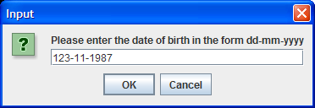 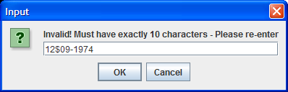

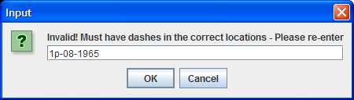 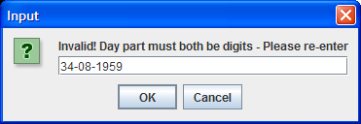 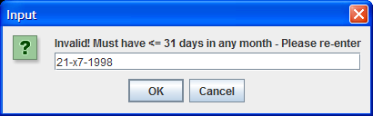

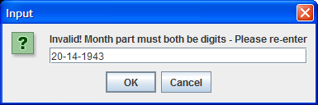

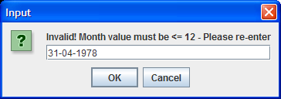

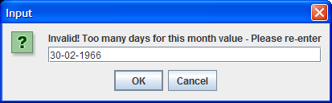 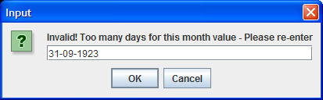

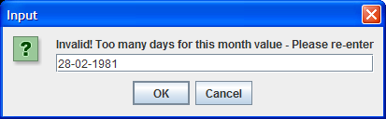

**… eventually the user enters a valid date of birth and it is displayed on a message dialog**

